How to fill fields in a PDF document
Download the latest version of Adobe Acrobat Reader DC
- Open file in PDF Reader (If needed free download https://get.adobe.com/reader/)

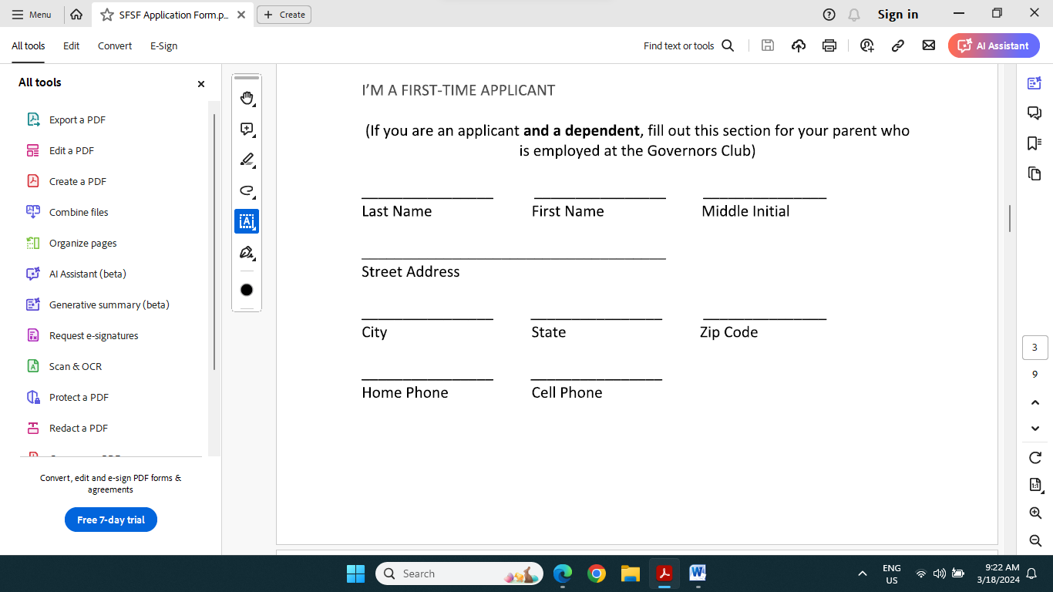

- Click on Letter box to the left of the document to enable filling out form.
- Click on field and type required information in text box. Cursor will have Ab symbol
- Fill out all relevant lines on the application form by either tabbing or scrolling down and clicking on the entry field. You may have to click twice on a field to get the text cursor (Ab).
When you are writing the essay you will have to hit return at the end of each line of text.
Click on close button and save file on your device with your name (Save As).

